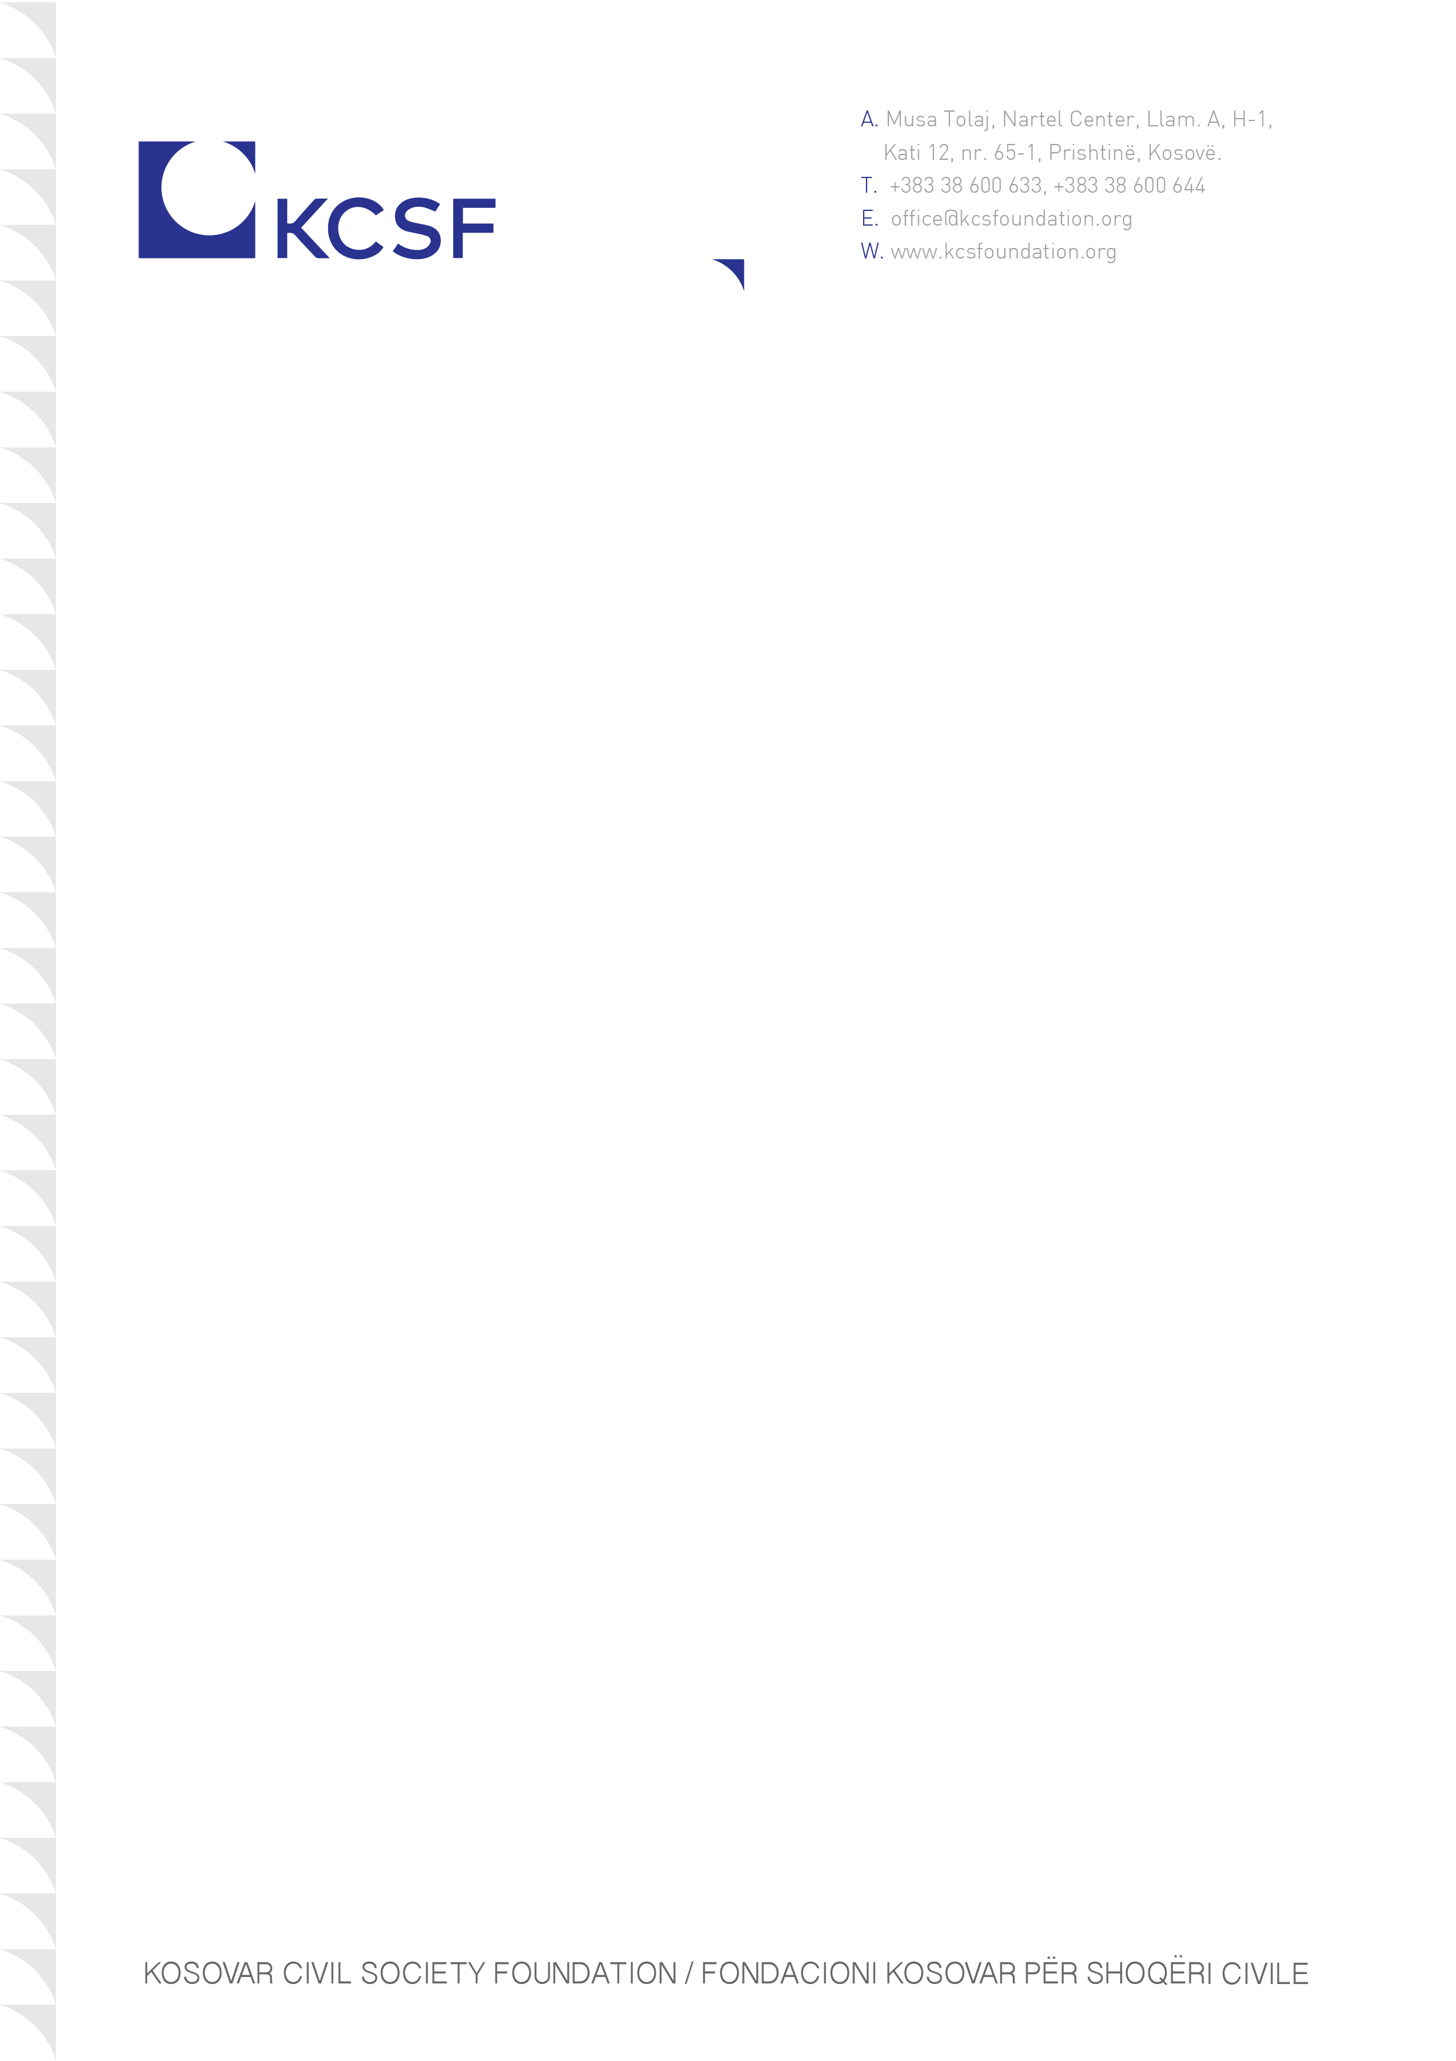

Annex 1: Terms of Reference
Contract Tittle: |  | Expert for contextual adaptation of the curricula for the Community Leadership Academy (CLA)
Program: |  | Citizen Engagement Activity (CEA)
Reference No. |  | 02/2022

BACKGROUND
About KCSF
The Kosovar Civil Society Foundation (KCSF) is a leading organization in supporting civic initiatives in Kosovo since 1998. KCSF provides funding to civil society through advanced re-granting mechanisms and systems, builds capacity and knowledge for the sector through the KCSF Center, as well as protects and promotes civic space and the environment for civil society activism in Kosovo and beyond, through policy research, advocacy, and mobilization of the sector. KCSF believes that a strong civil society with real involvement of citizens in its work is a key element for inclusive, transparent and accountable governance, which contributes to the transformation of Kosovo into a democratic society with a perspective of European integration and an advanced socio-economic situation.
Citizen Engagement Activity (CEA)
The Citizen Engagement Activity (CEA) in Kosovo aims to support Civil Society Organizations (CSOs) to build constituencies, diversify their resource and partner base, and affect change by connecting different actors around locally driven development solutions, and to enhance government accountability. CEA is a five-year program (2021-2026) supported by the United States Agency for International Development (USAID) and implemented by the Kosovar Civil Society Foundation (KCSF).
Building on long-standing experience and expertise of KCSF in civil society development, including recent approaches towards a more constituent-based civil society, and complementing it with the mandate and expertise of local partners and proven models of international partners, CEA will contribute towards the achievement of the following objectives:
Objective 1: Strengthened civil society links to constituencies, energized community activism and increased demand for accountability.
Objective 2: Established cross-sectoral partnerships and increased trust between CSOs, citizens, private sector, and public institutions.
Objective 3: Developed capacities of CSOs and an enabling regulatory environment to mobilize alternative domestic and diaspora resources.

Community Leadership Academy (CLA)
In the framework of the first project component, CEA, in cooperation with Street Law, will establish a Community Leadership Academy (CLA) that will cultivate a cohort of active youth that will form a basis of active citizens and constituents that will mobilize their peers around community issues in their respective localities. The goal of CLA is to create a cadre of grassroots level activists able to effectively organize and advocate for positive change in their communities. The Academy aims to provide the knowledge and skills of participants to organize their communities, create networks with CSOs, public officials, media and the private sector to explore solutions to problems in their communities.
The Academy will have 9 editions to be organized in 9 different locations throughout Kosovo. The direct target group for the Academy are young men and women, aged 18-24, with a 50/50 gender distribution among participants. One cohort of the Academy is expected to train 20-25 participants.
SCOPE OF WORK
Expert for contextual adaptation of the curricula for the Community Leadership Academy (CLA)
Community Leadership Academy (CLA) will have a learner-centered, participatory teaching training curriculum to be developed by Street Law by drawing on their lessons and texts on topics such as Democracy for All, Human Rights for All, and Rule of Law Matters. The curriculum will incorporate the Deliberations methodology which teaches participants to explore both sides of a contested public policy issue, to analyze arguments, and to learn how to search for consensus across differences. The curriculum will include a participant workbook and a trainer’s guide to be prepared by Street Law.
A very important step in this process is the adaptation of the curricula to the Kosovar context. Adaption should ensure that the curricula fits the Kosovar setting by including, but not limited to, Kosovo specific topics, case studies, and examples.
For this purpose, KCSF aims to engage a short-term local expert (STLE) that fulfils the following requirements:
- Has experience on issues relating to democracy, human rights, rule of law, and youth participation;
- Has excellent understanding of political, economic and cultural context of Kosovo;
- Has fair knowledge on formal and/or non-formal education in Kosovo;
- Has proven experience in conducting similar relevant assignments, preferably with the same target group;
- Is very familiar with relevant civil society developments in Kosovo;
- Demonstrates excellent analytical and reporting skills.

The input to be provided by the STLE entails:
- Provision of Kosovo-specific information, context and cultural applicability of curricula, the background of potential participants, and other local guidance through direct conversations with Street Law. Also, during this very first phase, the STLE will work closely with KCSF to incorporate the organization’s knowledge and experience into the discussions with Street Law.

- Following the initial draft of the curricula to be submitted by Street Law, STLE will review the material and provide detailed feedback to KCSF. This will involve overall contextualization and information to be collected through two workshops with youth and youth CSOs to be organized by KCSF. The workshops with youth will analyze and assess if the curricula is able to transfer the desired theoretical and practical knowledge and skills to achieve the goal of CLA. The recommendations for revisions from workshops will be passed on to Street Law to incorporate them in the final draft. In addition, STLE will also provide Kosovo specific topics, case studies and examples and incorporate them in the curricula.
MAIN OUTPUTS/ DELIVERABLES AND TIME FRAME
The contracted expert/s will be responsible for submitting the below indicated main outputs/deliverables:
- Analyze and provide written feedback to the draft curricula submitted by Street Law. The feedback should be clear and specific for Street Law to understand the relevant Kosovo context. In addition, the expert should compile a collection of case studies and examples from Kosovo to feed the curricula design and implementation and prove readiness to participate in meetings with KCSF and Street Law on the same subject (16 working days).
- Drafts the plan and content for two workshops with youth and CSOs representing youth for contextual adaptation of Curriculum and support KCSF to organize the workshops (4 working days).
The foreseen tasks are expected to be accomplished by 15 Jun 2022.
WORKING LANGUAGE
The working language for the review process is English.
REQURIED DOCUMENTS FOR APPLICATION
Interested applicants should submit the following documents:
- CV with more information on relevant knowledge and experience;
- A brief description of the work methodology along with a general implementation plan;
- List of relevant conducted assignments and description of tasks;
- Financial offer quoted in Euro.
Price must be quoted free of all duties, taxes, and other charges, including VAT, as the KCSF is exempt from such charges. The price should cover all fees such professional, travel and/or administrative expenses.

All documents must be sent by e-mail to the tender@kcsfoundation.org, no later than 4 April, 2022. Any questions about this call can be directed to the same email by 30 March, 2022, at 16:00.
A selected committee from KCSF will make the assessment and selection of applications. After the initial evaluation of the applications, KCSF reserves the right to request additional documents (evidence) from the expert, if it deems it necessary. KCSF reserves the right to negotiate the financial offer.
DUTY STATION AND TRAVEL
The contracted STLE is expected to reside in Kosovo during the completion of the task. During the workshops and meetings, the contractor should be present in person or online if the meeting is to take place virtually. While performing the required services, the selected contractor should make sure to abide to the anti-Covid measures that might be in place.
REPORTING AUTHORITY
The reporting authority is KCSF. KCSF reserves the right to request additional information, corrections and/or necessary revisions.
TERMS AND CONDITIONS
Definitions
“Contract” means the Contract Agreement entered between KCSF and the Successful Applicant.
“Contract Price” means the price or prices offered at which will form the Contract Agreement.
“Intellectual Property Rights (IPR)” means any and all copyright, moral rights, trademark, patent and other intellectual and proprietary rights, title and interests worldwide whether vested contingent, or future, including without limitation all economic rights and all exclusive rights to reproduce, fix, adapt, modify, translate, create derivative works from extract or re-utilize data from, introduce into circulation, publish, enter into computer memory, otherwise use any portion or copy in whole or in part, in any form, directly or indirectly, or authorize or assign others to do so.
“Awarded Applicant” means applicant selected through this process.
Notification of Award or Work Order
After selection of the Successful Applicant and after obtaining internal approvals, KCSF will notify the selected Applicant.
Upon the successful Applicant accepting the Work Order and signing the agreement, KCSF will notify each unsuccessful Applicant. KCSF reserves the right to cancel in all or adapt the TORs and relaunch the call for offers.
Price
Price shall remain fixed as per the Financial Bid accepted by KCSF. There shall be no increase in price for any reason whatsoever. Therefore, no request for any escalation of the cost / price shall be entertained.

Work Order cancellation
KCSF reserves the right to cancel the work order in the event of one or more of the following situations, that are not occasioned due to reasons solely and directly attributable to KCSF alone:
- Serious discrepancy observed during performance as per the scope of engagement.
- If the Applicant makes any statement or encloses any form which turns out to be false, incorrect and/or misleading or information submitted by the Applicant turns out to be incorrect and/or conceals or suppresses material information.
Other terms
All information provided to the awarded Applicant shall be treated in strict confidentiality by KCSF.
Termination and other terms and conditions are specified on the agreement.

Based in Maryland, USA, Street Law, Inc. advances justice through classroom and community education programs that empower people with the legal and civic knowledge, skills, and confidence to bring about positive change for themselves and others. https://www.streetlaw.org/

